Chapter 6, Problem 25.

(a) Show that the voltage-division rule for two capacitors in
series as in Fig. 6.59(a) is

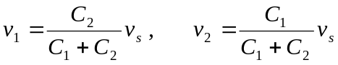

assuming that the initial conditions are zero.

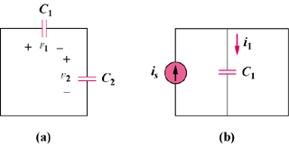

Figure 6.59
For Prob. 6.25.

(b) For two capacitors in parallel as in Fig. 6.59(b), show that the
current-division rule is

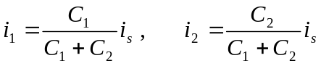

assuming that the initial conditions are zero.

